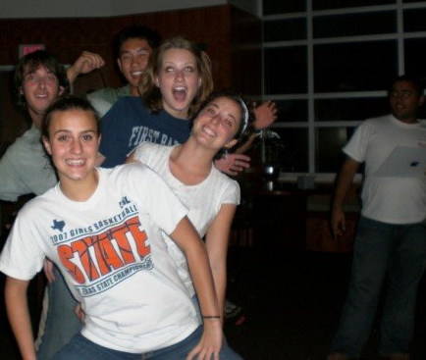
UH Terry Scholar Student Organization
uhterryofficers@gmail.com

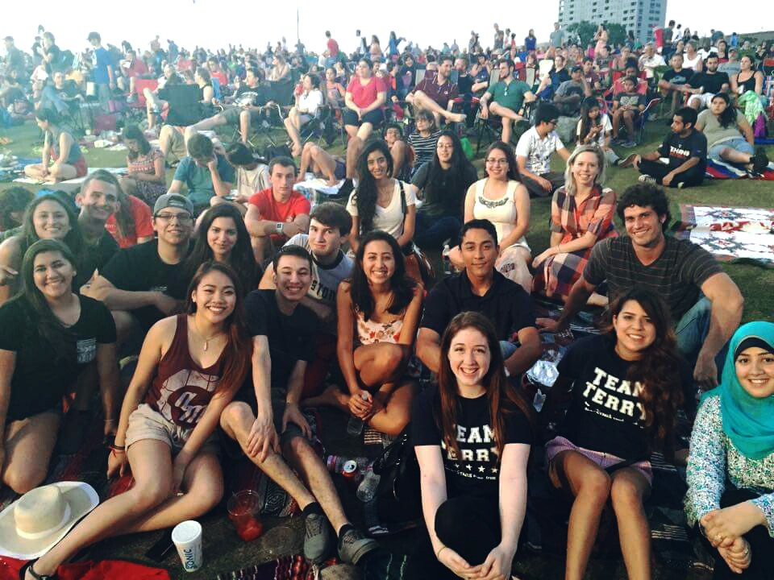
  - Friday, September 4, 2015
- Announcements – (Kyle/President)
  - New Coordinators!
    - Colleen and Brenda
    - Uhterry@uh.edu
  - Structural Changes to Organization
    - Transfer Liaison
    - Committees- sign up after meeting
- Social/Mentor Events and Intramurals – (Elizabeth/V.P.)
  - Scavenger Hunt
Terrys at the Shakespeare Summer Social!
    - September 4th (TODAY) @ 6PM
    - Wear comfortable shoes and clothing!
- Important Information – (Sarah/Secretary)
  - Terry Banquet
    - Mandatory for ALL scholars!
    - October 6th, 2015
      - Check-in at 5 p.m.
    - RSVP online
  - Next General Meeting
    - Friday Oct. 3nd, 4 p.m.
  - Terry Website!
    - uhterryscholars.weebly.com
  - UH Terry Scholar Twitter account!
    - Follow us @UHTerryScholars
  - UH Terry Instagram
    - @uhterryscholars
  - CHECK YOUR EMAILS!
  - CHECK THE FACEBOOK PAGE!

- HAPPY LABOR DAY WEEKEND!

    - Meet back in front of CV1, at the Statues.
  - Intramural Sports
    - Register for an imleagues.com account!
    - Intramural Announcement
    - Team Terry Shirts
  - Ice Cream Social!
    - Thursday, September 24th
    - Large Classroom in Honors
    - Food, drinks and more!
- Shirt Ideas – (Vivian/Historian)
  - New merchandise ideas
  - Fundraiser Shirt!
  - Fundraising Committee
  - Dodgeball tournament?
- Terry Merchandise – (Aydan/Treasurer)
  - Last year’s shirts and apparel on sale!
  - Order merchandise!
  - Pick up mentee shirts!
- Important Events – (Karely/Service Officer)
  - Houston Food Bank
    - Saturday September 12th, 2015
      - 1 to 4 p.m.
      - Register online to volunteer!
  - Service Committee
Freshmen Speed-Dating!

