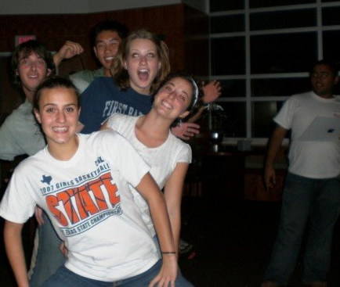
UH Terry Scholar Student Organization
uhterryofficers@gmail.com
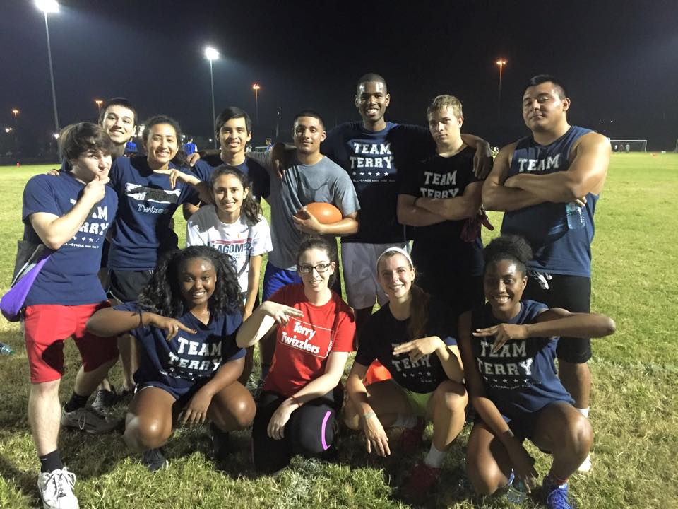
  - Friday, October 2nd, 2015
- Announcements – (Kyle/President)
  - Guest Speaker- Cory Jackson
    - Project LEAD
      - Nehemiah Center/ Yellowstone
    - Contact him if interested in mentoring
  - TAP Night
    - Thurs, November 12th from 7-9 p.m. in SC
    - Who do you want there?
      - Fill out Google Form!
- Social/Mentor Events and Intramurals – (Elizabeth/V.P.)
Team Terry after Wednesday night’s Flag Football Win!
  - Intramural Sports
    - Flag Football
      - Every Wednesday at 8:30 p.m.
      - Register for an imleagues.com account!
- Transfer Announcements –(Magdalene/TL)
  - Happy Hour was a success!
  - Bi-Weekly lunch- Week of Oct. 11th!
  - Email Magdalene with ideas for events - uhterryofficers@gmail.com
- Important Information – (Sarah/Secretary)
  - Terry Banquet
    - Mandatory for ALL scholars!
    - October 6th, 2015
      - Check-in at 5 p.m.
  - Next General Meeting
    - Friday, NOV. 6th, 4 to 5:30 p.m.
  - UH Terry Scholar Twitter account!
    - Follow us @UHTerryScholars
  - CHECK YOUR EMAILS!
  - CHECK THE FACEBOOK PAGE!

- HAPPY OCTOBER!!

      - Wear Team Terry Shirts and no pockets!
  - October Events
    - Pho Night
      - October 9th at 6p.m. at Son Nam
    - Fall Party
      - October 29th at 6 p.m. in SC
      - Wear a costume!!
      - Food, drinks and more!
- Shirt Ideas – (Vivian/Historian)
  - Fundraiser Shirt Announcement!
  - 2015 Transfer Shirts on the way!
- Terry Merchandise – (Aydan/Treasurer)
  - Order merchandise!
    - Pay with Aydan after the meeting!
  - Venmo Instructions*
- Important Events – (Karely/Service Officer)
  - Relay for Life Team Meeting
    - Wednesday October 8th, 2015
      - 5 p.m in SC Food Court
  - Zoo Boo
    - Saturday October 18th at Houston Zoo
      - Scheduled from 9a.m. to 1p.m.
      - Will Carpool from CV1 (8:15-ish)*

