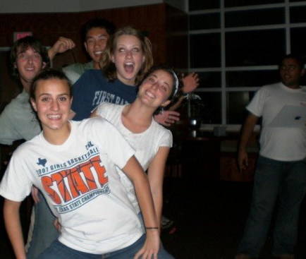
UH Terry Scholar Student Organization
uhterryofficers@gmail.com
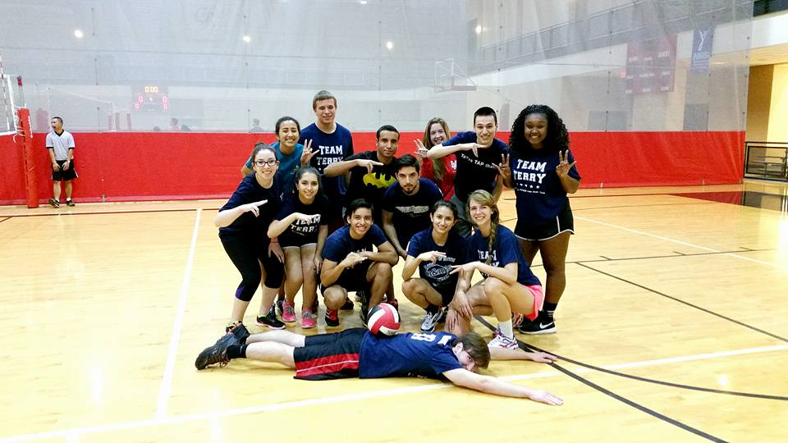
  - Friday, November 6th, 2015
- Announcements – (Kyle/President)
  - TAP Night
    - Thurs, November 12th from 7-9 p.m. in SC
- Social/Mentor Events and Intramurals – (Elizabeth/V.P.)
  - Intramural Sports
    - Flag Football
      - Mondays at 5:30 p.m.*(subject to change)
      - Need committed girls to show up!
    - Volleyball
      - UNDEFEATED- play-offs TBA
Team Terry after one of their MANY Volleyball WINS!
    - Sign up for DODGEBALL!
  - November Events
    - Thanksgiving Potluck
- Transfer Announcements –(Magdalene/TL)
  - Happy Hour: NOVEMBER 20th at Calhoun’s Rooftop
    - YOU suggest TIME!
  - Bi-Weekly lunch
  - Email Magdalene with ideas for events - uhterryofficers@gmail.com
- Important Information – (Sarah/Secretary)
  - TERRY TUESDAY NEWSLETTER!
  - Last “Meeting”-
    - Saturday, December 5th at 6:00 p.m.
  - UH Terry Scholar Insta/Twitter accounts!
    - Follow us @UHTerryScholars
  - CHECK OUT OUR WEBSITE
    - uhterryscholars.weebly.com
  - CHECK THE FACEBOOK PAGE!

- HAPPY NOVEMBER!!

      - Tuesday, November 10th, 2015
      - Food will be served ~8-ish at CV1
    - Terry Ice Skating
      - November 21st at 6:30 p.m. to 9:00 p.m.
      - Galleria Mall- Special Lights and Music
      - First 10 people to RSVP will be paid for!!
- Fundraising – (Vivian/Historian)
  - Fundraiser Committee!
    - Dodgeball tournament?!?!
  - Windbreaker orders and payments!
- Terry Merchandise – (Aydan/Treasurer)
  - Order Winter merchandise!
    - Pick up and pay with Aydan after the meeting!
  - Venmo Instructions*
  - Food Suggestions!
- Service Events – (Karely/Service Officer)
  - Relay for Life Kick-Off!
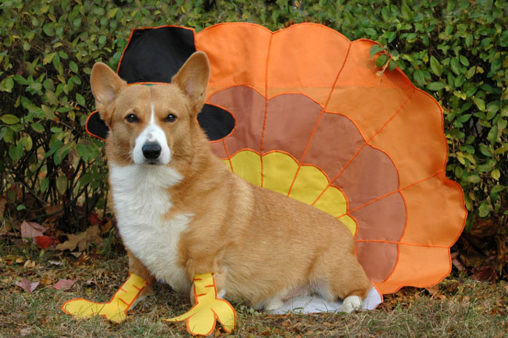
    - Tuesday, November 17th, 2015
      - Student Center Games Room
      - Bowling, Food, Games, Etc.
  - Herman Park Annual Run Volunteering!
    - Saturday, November 14th at Herman Park
      - Scheduled from 6:00 a.m. to 11:30 a.m.
      - Will Carpool from CV1 (5:30-ish)*
      - Cheering, handing out water, helping with
After-party, music, food, etc.

